NAME : SHYAM SUNDAR
REG NO : 241801268
DEPT : AI&DS
EXP NO : 4

2. Show the structure of departments the table. Select all the data from it.
Ans
Desc employee1;
select * from employee1;

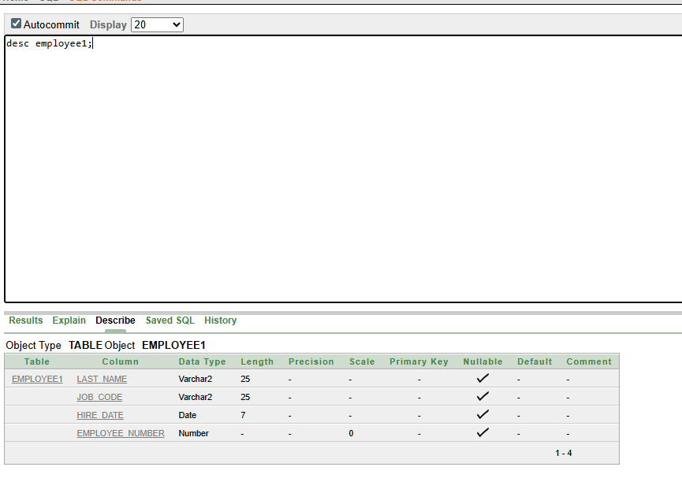

3. Create a query to display the last name, job code, hire date, and employee number for each
employee, with employee number appearing first.
Ans
select employee_number,last_name,job_code,hire_date
from employee1;
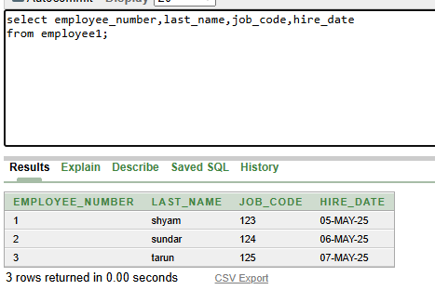

4. Provide an alias STARTDATE for the hire date.
Ans
select hire_date as stardate
from employee1;

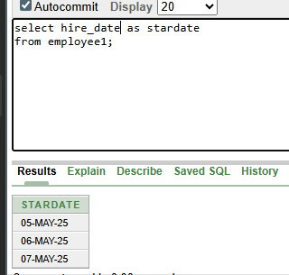

5. Create a query to display unique job codes from the employee table.
Ans
select distinct job_code
from employee1;

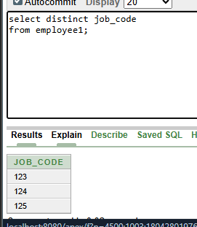

6. Display the last name concatenated with the job ID , separated by a comma and space, and
name the column EMPLOYEE and TITLE.
Ans
select last_name||','||job_code as "EMPLOYEE and TITLE"
from employee1;
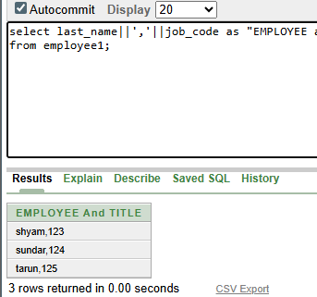

7.Create a query to display all the data from the employees table. Separate each column by a
comma. Name the column THE_OUTPUT.
Ans
select last_name||','||job_code||','|| hire_date||','||employee_number as "OUTPUT"
from employee1;
